**Bug Report – TutorialsNinja**

|  |  |  |  |  |
| --- | --- | --- | --- | --- |
| **Bug#** | **Description** | | **Severity** | |
| TU1-I1 | 'Thank you for registering' email is not received to the registered email address after registering an account | | Minor | |
| TU1-I2 | User is able to register an account by providing an invalid phone number | | Minor | |
| TU1-I3 | 'Privacy Policy' Checkbox field in 'Register Account' page is not marked with red colour * symbol | | Minor | |
| TU1-I4 | 'Telephone' field in 'Register Account' page is accepting the spaces and not showing warning message | | Minor | |
| TU1-I5 | 'Password' and 'Password Confirm' fields in 'Register Account' page are accepting simple passwords | | Major | |
| TU1-I6 | Leading and Trailing spaces are accepted by the text fields in the 'Register Account' page | | Minor | |
| TU1-I7 | User is getting logged out on clicking Browser back button | | Critical | |
| TU1-I8 | User is getting logged in automatically on browsing back immediately after logout | | Major | |
| TU1-I9 | User is getting logged in automatically on browsing back immediately after logout | | Major | |
| TU1-I10 | User is not automatically getting logged out of the Application after 30 minutes of inactivity | | Minor | |
| TU1-I11 | User is not getting logged out in one browser, when logged out in another browser | | Minor | |
| TU1-I12 | Email address is not getting carry forwarded from the 'Login' page to 'Forgot Your Password' page | | Minor | |
| TU1-I13 | Using tab keyboard key is not highlighting the 'Search in subcategories' checkbox field | | Minor | |
| TU1-I14 | Negative, Null and Zero values are accepted by the Qty field in Product Display Pages | | Minor | |
| TU1-I15 | Warning message informing the User to provide positive quantity is not getting displayed on updating the quantity with negative, zero or blank in the 'Shopping Cart' page | | Minor | |
| TU1-I16 | $8 is displayed instead of $5 in the displayed 'Estimate Shipping & Taxes' dialog | | Major | |
| TU1-I17 | User can provide future date for the 'Order Date' field while returning the order | | Major | |
| TU1-I18 | Page text is not displayed in the 'About Us', 'Delivery Information', 'Privacy Policy' and 'Terms & Conditions' page | | Minor | |
| TU1-I19 | Normal User who has not registered for the Affiliate account is able to login from 'Affiliate Login' section | | Minor | |
| TU1-I20 | Options are not displayed in the 'Select' dropdown list of 'Canon EOS 5D' product display page | | Major | |
| TU1-I21 | Logo of the Application is missing, instead 'Your Text' is getting displayed | | Minor | |
| TU1-I22 | Clicking on the first Hero image is taking us to a wrong Product Display Page | | Minor | |
| TU1-I23 | A blank 'Contact Us' page is displayed on submitting the form in 'Contact Us' page | | Minor | |
| Bug Id | | TU1-I1 | |

|  |  |
| --- | --- |
| Brief Summary | 'Thank you for registering' email is not received to the registered email address after registering an account |

|  |  |
| --- | --- |
| Severity | Minor |

**Steps to Reproduce:**

1. Open the Application URL

2. Click on 'My Account' dropmenu

3. Select 'Register' option

4. Enter the new User valid details into the 'Register Account' page

5. Select the 'Privacy Policy' checkbox option

6. Click on 'Continue' button

**Expected Result:**

User Account should be created and an email with the subject 'Thank you for registering' should be received by the registered email address.

**Actual Result:**

User Account is getting created, but the email with subject 'Thank you for registering' is not received to the registered email address.

|  |
| --- |
| Screenshot |

Not Applicable

|  |  |
| --- | --- |
| Bug Id | TU1-I2 |

|  |  |
| --- | --- |
| Brief Summary | User is able to register an account by providing an invalid phone number |

|  |  |
| --- | --- |
| Severity | Minor |

**Steps to Reproduce:**

1. Open the Application URL

2. Click on 'My Account' dropmenu

3. Select 'Register' option

4. Enter valid details into the fields displayed on the 'Register Account' page

5. Enter invalid phone number say **abcde**into the 'Telephone' field

6. Select 'Privacy Policy' checkbox field

7. Click on 'Continue' button

**Expected Result:**

Warning message should be displayed informing the Users about the invalid phone number

**Actual Result:**

Warning message is not getting displayed, instead User account is getting created with invalid phone number

|  |
| --- |
| Screenshot |

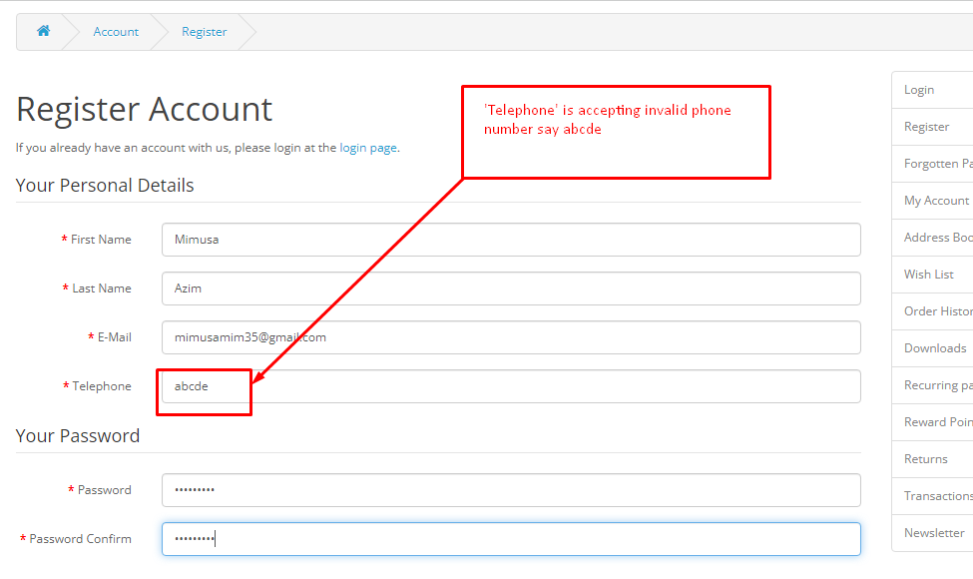

|  |  |
| --- | --- |
| Bug Id | TU1-I3 |

|  |  |
| --- | --- |
| Brief Summary | 'Privacy Policy' Checkbox field in 'Register Account' page is not marked with red colour * symbol |

|  |  |
| --- | --- |
| Severity | Minor |

**Steps to Reproduce:**

1. Open the Application URL in any browser

2. Click on 'My Account' Dropmenu

3. Select 'Register' option

4. Check the 'Privacy Policy' checkbox field in the displayed 'Register Account' page

**Expected Result:**

'Privacy Policy' check box field should be marked with red colour * symbol

**Actual Result:**

'Privacy Policy' check box field is mandatory but not marked with red colour * symbol.

|  |
| --- |
| Screenshot |

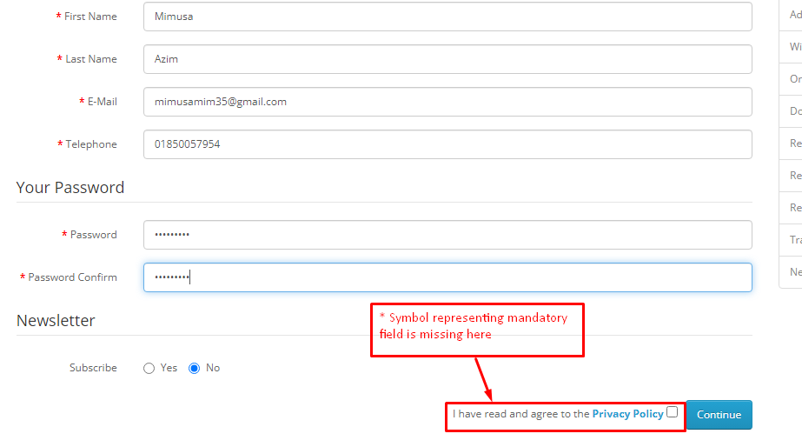

|  |  |
| --- | --- |
| Bug Id | TU1-I4 |

|  |  |
| --- | --- |
| Brief Summary | 'Telephone' field in 'Register Account' page is accepting the spaces and not showing warning message |

|  |  |
| --- | --- |
| Severity | Minor |

**Steps to Reproduce:**

1. Open the Application URL in any browser
2. Click on 'My Account' dropmenu
3. Selection 'Register' option
4. Enter spaces into all the mandatory fields including 'Telephone' field
5. Select the 'Privacy Policy' checkbox field
6. Click on 'Continue' button

**Expected Result:**

Warning message informing the User to enter the Telephone field should be displayed

**Actual Result:**

Telephone field is accepting the spaces and no field level warning message is displayed for this field.

|  |
| --- |
| Screenshot |

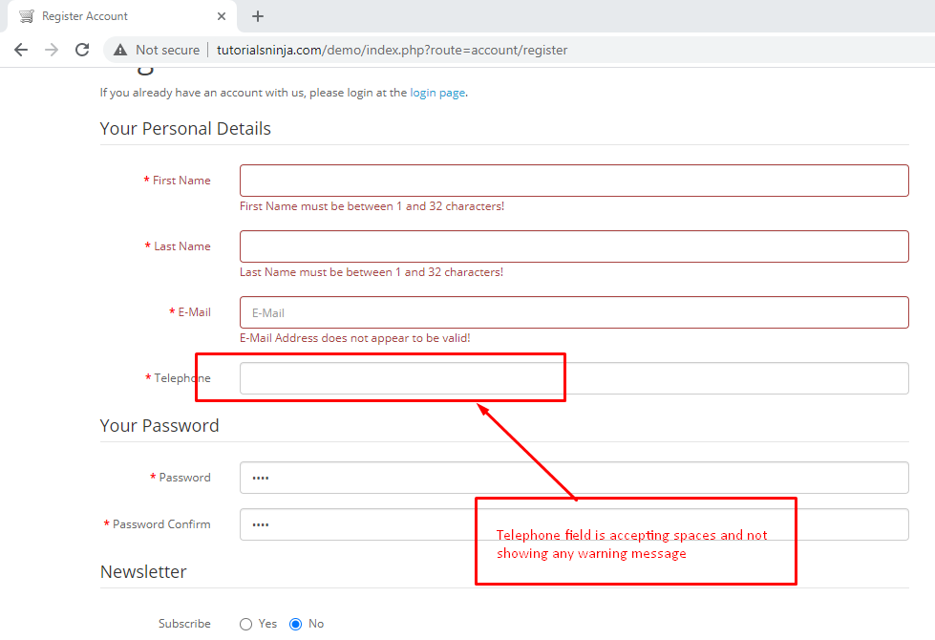

|  |  |
| --- | --- |
| Bug Id | TU1-I5 |

|  |  |
| --- | --- |
| Brief Summary | 'Password' and 'Password Confirm' fields in 'Register Account' page are accepting simple passwords |

|  |  |
| --- | --- |
| Severity | Major |

**Steps to Reproduce:**

1. Open the Application URL in any browser
2. Click on 'My Account' dropmenu
3. Select 'Register' option
4. Enter details into all the mandatory fields
5. Enter simple password say 'abcd' into the 'Password' and 'Password Confirm' fields
6. Select 'Privacy Policy' checkbox field
7. Click on 'Continue' button

**Expected Result:**

Warning message informing the User to enter a password matching the complexity standards should be displayed

**Actual Result:**

Simple password got accepted and there is no warning message regarding the complexity standards of the Password.

|  |
| --- |
| Screenshot |

Not Applicable

|  |  |
| --- | --- |
| Bug Id | TU1-I6 |

|  |  |
| --- | --- |
| Brief Summary | Leading and Trailing spaces are accepted by the text fields in the 'Register Account' page |

|  |  |
| --- | --- |
| Severity | Minor |

**Steps to Reproduce:**

1. Open the Application URL in any browser
2. Click on 'My Account' dropmenu
3. Select 'Register' option
4. Enter leading and trailing spaces to the text fields in the 'Register Account' page
5. Select 'Privacy Policy' checkbox field
6. Click on 'Continue' button

**Expected Result:**

Leading and Trailing spaces should not be accepted by the text fields in the 'Register Account' page

**Actual Result:**

Leading and Trailing spaces are accepted by the text fields in the 'Register Account' page and account is getting created.

|  |
| --- |
| Screenshot |

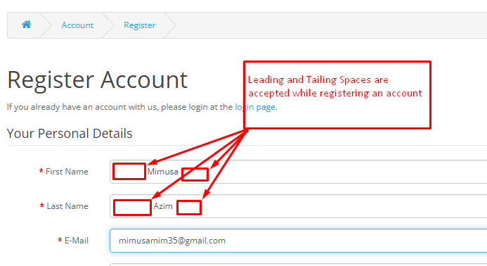

|  |  |
| --- | --- |
| Bug Id | TU1-I7 |

|  |  |
| --- | --- |
| Brief Summary | User is getting logged out on clicking Browser back button |

|  |  |
| --- | --- |
| Severity | Critical |

**Steps to Reproduce:**

1. Open Application URL in any browser
2. Click on 'My Account' dropmenu
3. Select 'Login' option
4. Enter valid email address into 'E-Mail Address' field and valid password into 'Password' field
5. Click on 'Login' button
6. Click on browser back button two times

**Expected Result**

User should not get logged out

**Actual Result**

User is getting logged out

|  |
| --- |
| Screenshot |

Not Applicable

|  |  |
| --- | --- |
| Bug Id | TU1-I8 |

|  |  |
| --- | --- |
| Brief Summary | User is getting logged in automatically on browsing back immediately after logout |

|  |  |
| --- | --- |
| Severity | Major |

**Steps to Reproduce:**

1. Login to the Application
2. Click on 'My Account' dropmenu
3. Select 'Logout' option
4. Click on browser back button

**Expected Result**

User should not get logged in automatically

**Actual Result**

User is getting logged in automatically

|  |
| --- |
| Screenshot |

Not Applicable

|  |  |
| --- | --- |
| Bug Id | TU1-I9 |

|  |  |
| --- | --- |
| Brief Summary | Password is visible in the Page Source code of the Password field of 'Login' page |

|  |  |
| --- | --- |
| Severity | Major |

**Steps to Reproduce:**

1. Open Application URL in any browser
2. Click on 'My Account' dropmenu
3. Select 'Login' option
4. Enter password into the 'Password' field on the 'Login' page
5. Click on 'Login' button
6. Inspect the 'Password' text field

**Expected Result:**

Password should not be visible in the Page Source code

**Actual Result:**

Password is getting displayed in the Page Source code as shown in the attached screenshot

|  |
| --- |
| Screenshot |

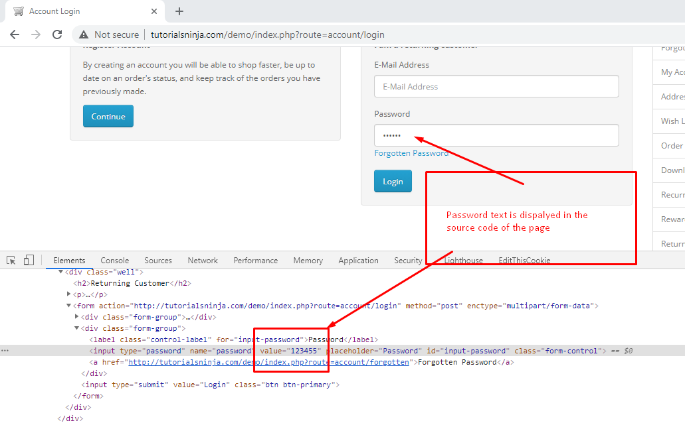

|  |  |
| --- | --- |
| Bug Id | TU1-I10 |

|  |  |
| --- | --- |
| Brief Summary | User is not automatically getting logged out of the Application after 30 minutes of inactivity |

|  |  |
| --- | --- |
| Severity | Major |

**Steps to Reproduce:**

1. Login to the Application with valid credentials
2. Don't perform any action for next 30 minutes
3. Try to perform any action after the above 30 minutes like Search a product etc.

**Expected Result:**

User should get automatically logged out

**Actual Result:**

User is not getting logged out

|  |
| --- |
| Screenshot |

Not Applicable

|  |  |
| --- | --- |
| Bug Id | TU1-I11 |

|  |  |
| --- | --- |
| Brief Summary | User is not getting logged out in one browser, when logged out in another browser |

|  |  |
| --- | --- |
| Severity | Minor |

**Steps to Reproduce:**

1. Login to the Application with same credentials in Chrome and Firefox Browser
2. Logout in Chrome browser
3. Check performing any action in Firefox browser

**Expected Result**

User should also get logged out in Firefox browser

**Actual Result**

User is not getting logged out automatically in Firefox browser

|  |
| --- |
| Screenshot |

Not Applicable

|  |  |
| --- | --- |
| Bug Id | TU1-I12 |

|  |  |
| --- | --- |
| Brief Summary | Email address is not getting carry forwarded from the 'Login' page to 'Forgot Your Password' page |

|  |  |
| --- | --- |
| Severity | Minor |

**Steps to Reproduce:**

1. Open Application URL
2. Click on 'My Account' dropmenu
3. Select 'Login' option
4. Enter email address into the 'E-Mail Address' text field
5. Click on 'Forgotten Password' link

**Expected Result:**

Email address given in Login page should get carry forwarded to 'Forgot Your Password' page

**Actual Result:**

Email address given in Login page is not getting carry forwarded to 'Forgot Your Password' page

|  |
| --- |
| Screenshot |

Not Applicable

|  |  |
| --- | --- |
| Bug Id | TU1-I13 |

|  |  |
| --- | --- |
| Brief Summary | Using tab keyboard key is not highlighting the 'Search in subcategories' checkbox field |

|  |  |
| --- | --- |
| Severity | Minor |

**Steps to Reproduce:**

1. Open Application URL
2. Click on 'Search' icon without entering any product name
3. In the displayed 'Search' page, continuously press 'Tab' keyboard key

Expected Result:

All the options on the 'Search' page should get highlighted/focused.

Actual Result:

'Search in subcategories' checkbox field is not highlighted or focused.

|  |
| --- |
| Screenshot |

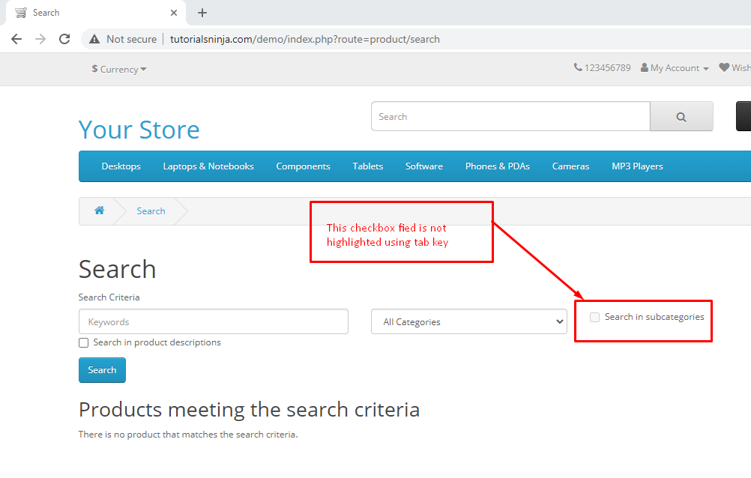

|  |  |
| --- | --- |
| Bug Id | TU1-I14 |

|  |  |
| --- | --- |
| Brief Summary | Negative, Null and Zero values are accepted by the Qty field in Product Display Pages |

|  |  |
| --- | --- |
| Severity | Minor |

**Steps to Reproduce:**

1. Open Application URL
2. Enter any Product Name say 'iMac' into the Search box field
3. Click on the button having Search icon
4. Click the Product displayed in the Search results
5. Change the quantity to Negative or Blank or Zero in the Qty field of Product Display Page
6. Click on 'Add to Cart' button

**Expected Result**

Warning message informing the User to enter a positive quantity into the Qty field should be displayed

**Actual Result**

Success message with text - Success: You have added Product to your shopping cart! is getting displayed

|  |
| --- |
| Screenshot |

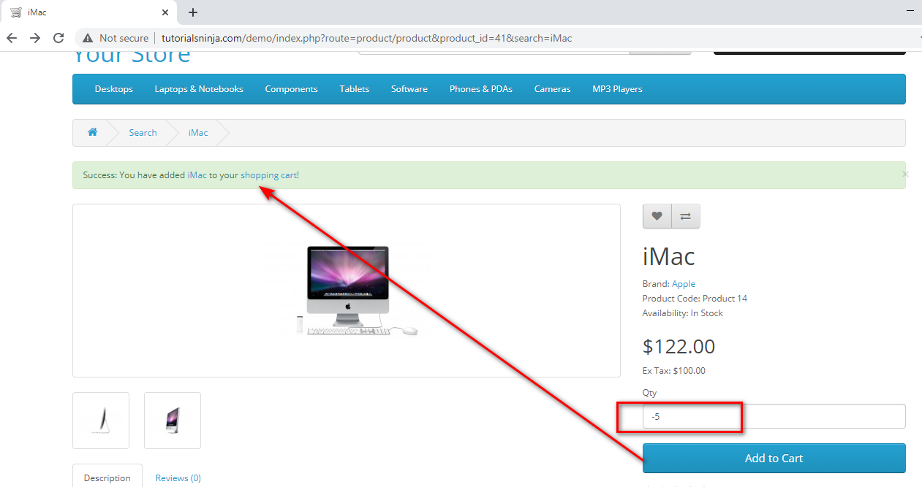

|  |  |
| --- | --- |
| Bug Id | TU1-I15 |

|  |  |
| --- | --- |
| Brief Summary | Warning message informing the User to provide positive quantity is not getting displayed on updating the quantity with negative, zero or blank in the 'Shopping Cart' page |

|  |  |
| --- | --- |
| Severity | Minor |

**Steps to Reproduce:**

1. Open Application URL
2. Enter any Product say 'iMac' in the Search box field
3. Click on 'Search' icon button
4. Click on 'Add to Cart' button on the product displayed in the Search Results page
5. Click on 'Shopping Cart' header option
6. Enter -5 into the Quantity field
7. Click on 'Update' icon option

**Expected Result**

Warning message informing the User to provide the positive quantity should be displayed

**Actual Result**

No warning message is getting displayed, instead 'Your shopping cart is empty!' is getting displayed

|  |
| --- |
| Screenshot |

Not Applicable

|  |  |
| --- | --- |
| Bug Id | TU1-I16 |

|  |  |
| --- | --- |
| Brief Summary | $8 is displayed instead of $5 in the displayed 'Estimate Shipping & Taxes' dialog |

|  |  |
| --- | --- |
| Severity | Major |

**Steps to Reproduce:**

1. Open any Application URL
2. Navigate to Shopping Cart page after adding a Product to Cart
3. Click on 'Estimate Shipping & Taxes' dialog
4. Enter Country say 'United States' into the 'Country' text field
5. Enter Region/State say 'California' into the 'Region/State' text field
6. Click on 'Get Quotes' button

**Expected Result**

$5 should be displayed in the 'Estimate Shipping & Taxes' dialog

**Actual Result**

For the first time after opening the browser and following the steps to reproduce, $8 is getting displayed in the 'Estimate Shipping & Taxes' dialog

|  |
| --- |
| Screenshot |

Not Applicable

|  |  |
| --- | --- |
| Bug Id | TU1-I17 |

|  |  |
| --- | --- |
| Brief Summary | User can provide future date for the 'Order Date' field while returning the order |

|  |  |
| --- | --- |
| Severity | Major |

**Steps to Reproduce:**

1. Login to the Account having few orders placed
2. Click on 'Order History' Right column option
3. Click on 'View' icon option of any order displayed in the table of 'Order History' page
4. Enter any future date into the 'Order Date' field in the displayed 'Product Returns' page
5. Provide/Select all the mandatory fields and click on 'Submit' button

**Expected Result**

Warning message informing the User to provide a valid date should be displayed

**Actual Result**

Future Date provided in the 'Order Date' field is accepted and return is placed

|  |
| --- |
| Screenshot |

Not Applicable

|  |  |
| --- | --- |
| Bug Id | TU1-I18 |

|  |  |
| --- | --- |
| Brief Summary | Page text is not displayed in the 'About Us', 'Delivery Information', 'Privacy Policy’ and 'Terms & Conditions' page |

|  |  |
| --- | --- |
| Severity | Minor |

**Steps to Reproduce:**

1. Open Application URL
2. Click on 'About Us' footer option or other footer options like 'Delivery Information', 'Privacy Policy’ and 'Terms & Conditions' page

**Expected Result**

Proper page text should be displayed in the pages

**Actual Result**

No page text is getting displayed in the page as shown in the attached screenshot

|  |
| --- |
| Screenshot |

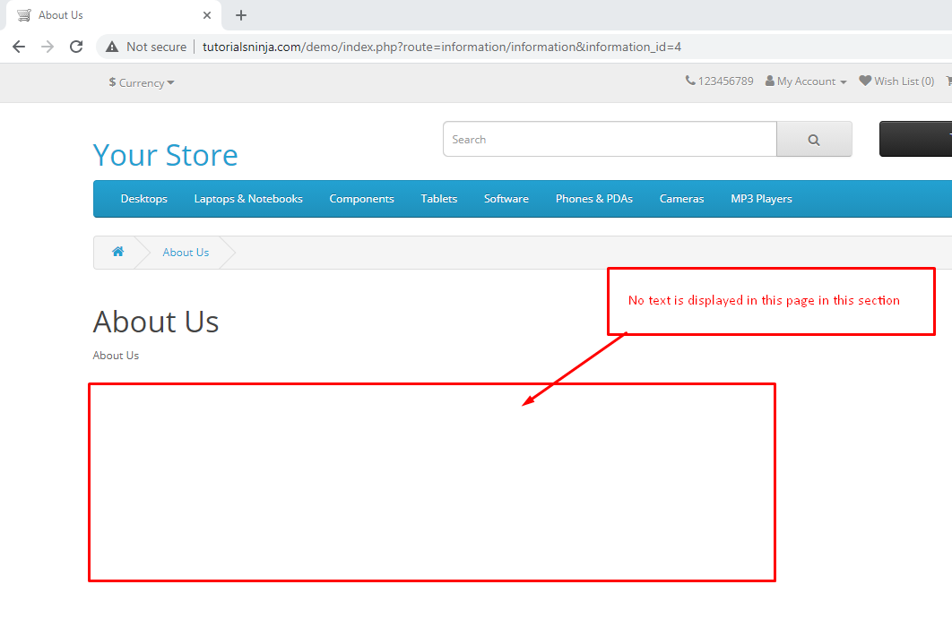

|  |  |
| --- | --- |
| Bug Id | TU1-I19 |

|  |  |
| --- | --- |
| Brief Summary | Normal User who has not registered for the Affiliate account is able to login from 'Affiliate Login' section |

|  |  |
| --- | --- |
| Severity | Major |

**Steps to Reproduce:**

1. Open Application URL
2. Click on 'Affiliate' footer link
3. Login from the 'Affiliate Program' page by providing credentials of the normal User who has not registered for an Affiliate account from the 'Affiliate Login' section
4. Click on 'Login' button

**Expected Result**

User doesn't have any affiliate account warning message should be displayed

**Actual Result**

Normal User not registered for affiliate account is able to login as shown in the attached screenshot

|  |
| --- |
| Screenshot |

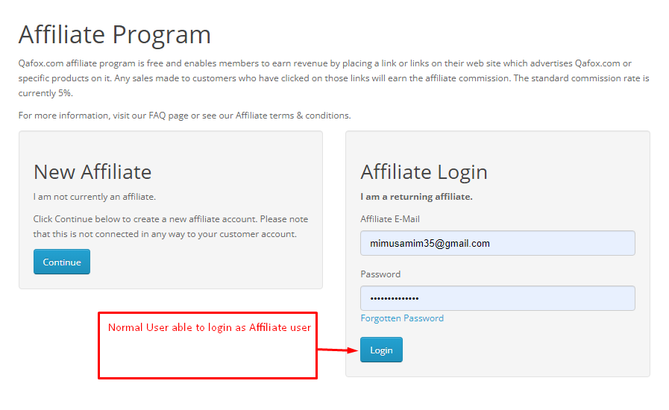

|  |  |
| --- | --- |
| Bug Id | TU1-I20 |

|  |  |
| --- | --- |
| Brief Summary | Options are not displayed in the 'Select' dropdown list of 'Canon EOS 5D' product display page |

|  |  |
| --- | --- |
| Severity | Major |

**Steps to Reproduce:**

1. Open Application URL
2. Enter 'Canon' text into Search text field
3. Click on 'Search' icon button
4. Click on the Product displayed in the Search results
5. Select any option from the 'Select' dropdown field displayed in the Product Display Page

**Expected Result**

Options should be displayed in the 'Select' dropdown field

**Actual Result**

Not a single option is displayed in the 'Select' dropdown field as shown in the attached screenshot

|  |
| --- |
| Screenshot |

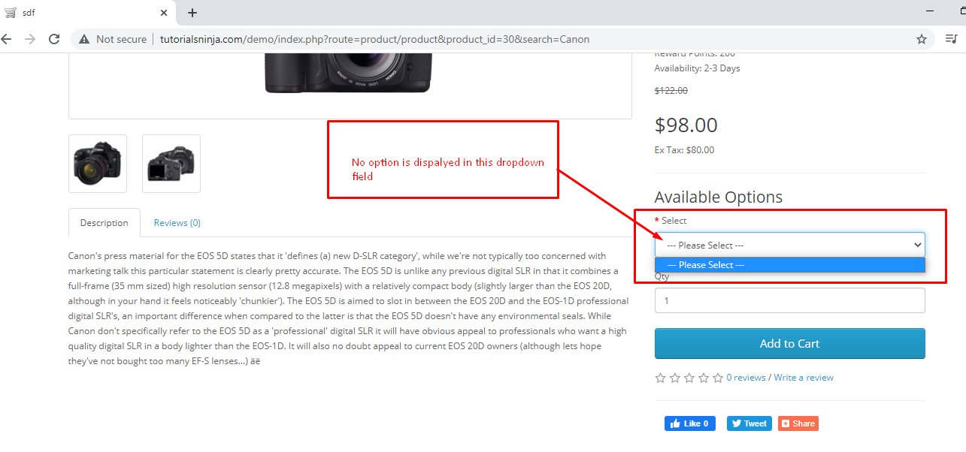

|  |  |
| --- | --- |
| Bug Id | TU1-I21 |

|  |  |
| --- | --- |
| Brief Summary | Logo of the Application is missing, instead 'Your Store' is getting displayed |

|  |  |
| --- | --- |
| Severity | Minor |

**Steps to Reproduce:**

1. Open Application URL

**Expected Result**

Logo should be displayed on the top left of the page

**Actual Result**

Logo is not getting displayed, instead 'Your Store' is displayed on the page as shown in the attached screenshot

|  |
| --- |
| Screenshot |

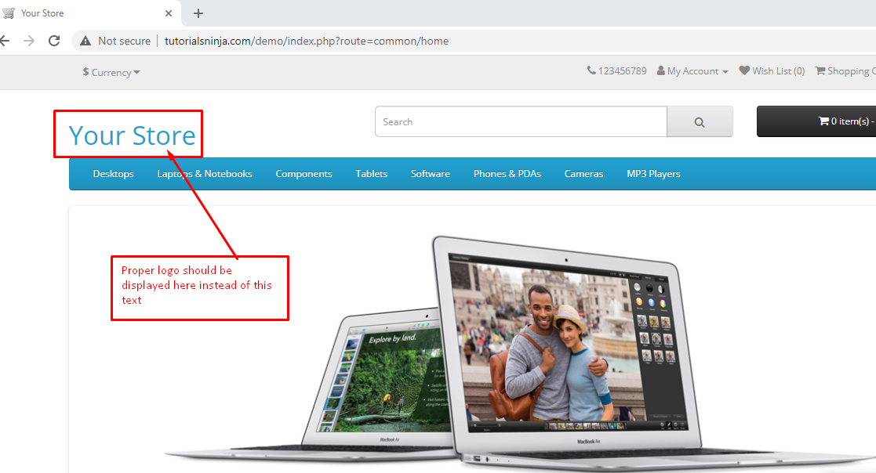

|  |  |
| --- | --- |
| Bug Id | TU1-I22 |

|  |  |
| --- | --- |
| Brief Summary | Clicking on the first Hero image is taking us to a wrong Product Display Page |

|  |  |
| --- | --- |
| Severity | Minor |

**Steps to Reproduce:**

1. Open Application URL
2. Click on the first Hero Image displayed in the Home page

**Expected Result**

User should be taken to correct Product Display Page

**Actual Result**

User is taken to a Product Display page of a Tab

|  |
| --- |
| Screenshot |

Not Applicable

|  |  |
| --- | --- |
| Bug Id | TU1-I23 |

|  |  |
| --- | --- |
| Brief Summary | A blank 'Contact Us' page is displayed on submitting the form in 'Contact Us' page |

|  |  |
| --- | --- |
| Severity | Minor |

**Steps to Reproduce:**

1. Open Application URL
2. Click on 'Contact Us' footer option
3. Enter the details into 'Your Name', 'E-Mail Address' and 'Enquiry' fields in the 'Contact Us' page
4. Click on 'Submit' button

**Expected Result**

Success Message with text - 'Your Enquiry has been Submitted!' should be displayed in the 'Contact Us' page

**Actual Result**

A blank 'Contact Us' page is getting displayed as shown in the attached screenshot

|  |
| --- |
| Screenshot |

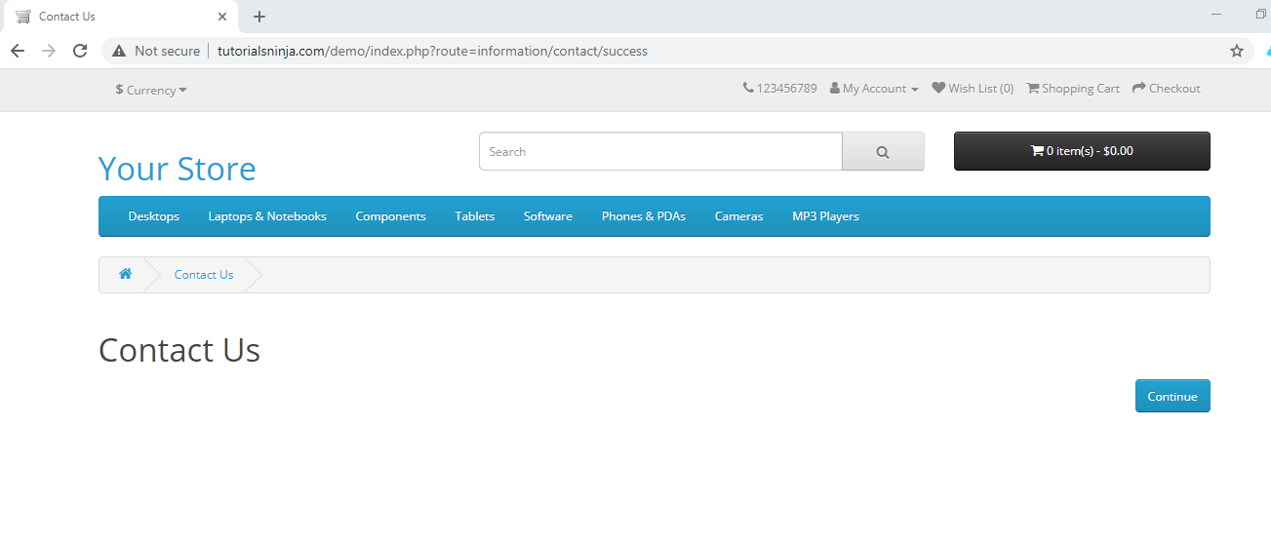

**Blockers:**

Tester is unable to execute few test cases due to the below blocker:

* Email system is not working.
* Need information on different Products and their weights
* Need Coupon codes
* Unable to Purchase Gift Certificate and test redeeming them, as there are no payments options like Credit Card, Debit Card, Bkash etc.